Asia

Asia is the largest continent and has the highest population. Around 60 percent of the world population lives in Asia. Most people in Asia live in China and India.

- What other countries can we find in Asia? (Use an atlas)

India
China
………………….
………………….
…………………..
……………………
……………………
…………………..

- Which country in Asia is the most similar to the Czech Republic and why?

- Write down at least 5 customs or traditions of the given country.

………………………
…………………………..
……………………………
………………………….
………………………….

- Try to explain the term „TRADITION “

- Which country in Asia differs the most from the Czech Republic. And why?

- Match the countries with the relevant religion.

India
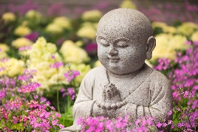
China

UAE

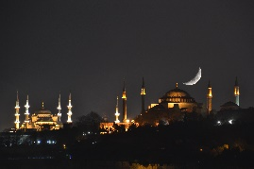
Russia

Nepal

South Korea
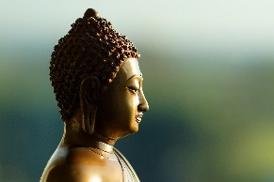
Vietnam

Japan

In Asia there are many different religions. Europe is less various in religion.

- Do you think individual countries should tolerate different religions?

- How do you understand the word tolerance?

- Do you tolerate different religions?

- Find out how many mosques and synagogues are in the Czech Republic.

- Why do we have mosques and synagogues in the Czech Republic?

